**The Influence of Net Migration, Unemployment, and Inflation on Economic Growth**

By: Rumeysa Yilmaz and Luis Heredia

**1.1 Introduction**

Economic growth is a valuable measure of a country's performance and a useful tool to analyze when comparing the prosperity and change in one country to another. While there are many factors that contribute to the growth or decline of an economy, our study will specifically examine its relationship with net migration, unemployment, and inflation. Our research question is: How do patterns of net migration, alongside unemployment rates and inflation, impact economic growth? We hypothesize that an increase in net migration to the United States will positively impact the economy, helping to mitigate the effects of unemployment and inflation, and ultimately contributing to a balanced growth equilibrium in the long run. This is because an increase in net migration means that there are more individuals coming into a country than there are leaving the country—which increases the country’s population. We believe that the increase in people would positively impact the labor market and allow for more economic activity, which would stimulate economic growth.

Surprisingly, there aren’t research papers that analyze the relationship between the variables that we are examining, which is what makes the results of our data particularly valuable for society. Our results could reveal helpful information to not only those at the Federal Reserve but also members of the public, as the economic performance of a country impacts all individuals. Having data on factors that are shape economic growth could be valuable in enacting monetary policy to best respond to various economic conditions.

**1.2 Data**

In this paper, we will be using time series data that spans a total of 63 years, from 1961 to 2023. In order to evaluate economic growth, we will use Real GDP—our dependent variable—which measures the total value of goods and services produced within the United States. Our independent variables in this study include: a) net migration—the difference between the inflow of immigrants and the outflow of emigrants; b) unemployment rate—the percentage of the labor force that is unemployed but actively seeking a job; c) inflation—the increase in the price of goods and services over time, which can provide assumptions about purchasing power, consumer spending, and costs related to employment and its overall impact on economic stability. We collected data from reputable sources, including the Federal Reserve and World Bank. **See appendix.**

**Summary Statistics:**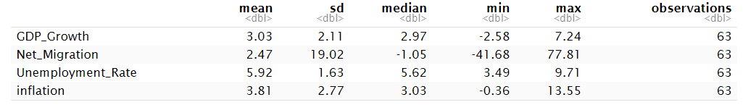

This data set contains 63 observations and four different variables. GDP Growth averages at about 3.03%, which is higher than the median, indicating the presence of outliers. This is typically reflected by a slight positive skew. It also has moderate variation shown by a standard deviation of 2.11, and has a minimum value of -2.58%, indicating a recession and a maximum of 7.24%, indicating an expansion. Net Migration has a mean of positive 2.47%, meaning that there are more people entering the country, since it is calculated by the number of immigrants minus the number of emigrants. It has a negative median, suggesting that there is a decrease in net migration compared to prior periods. Because we used percentage change as our unit of measurement, we see a high standard deviation. Unemployment Rate is mostly stable with a mean of 5.92%, which is close to the median of 5.62%. It also has a narrow range (3.49% to 9.71%) and low variability (SD: 1.63). Lastly, Inflation has an average of 3.81%, close to the median, with moderate variability (SD: 2.77), spanning deflationary periods (-0.36%) to high inflation (13.55%).

**Data visualization:** 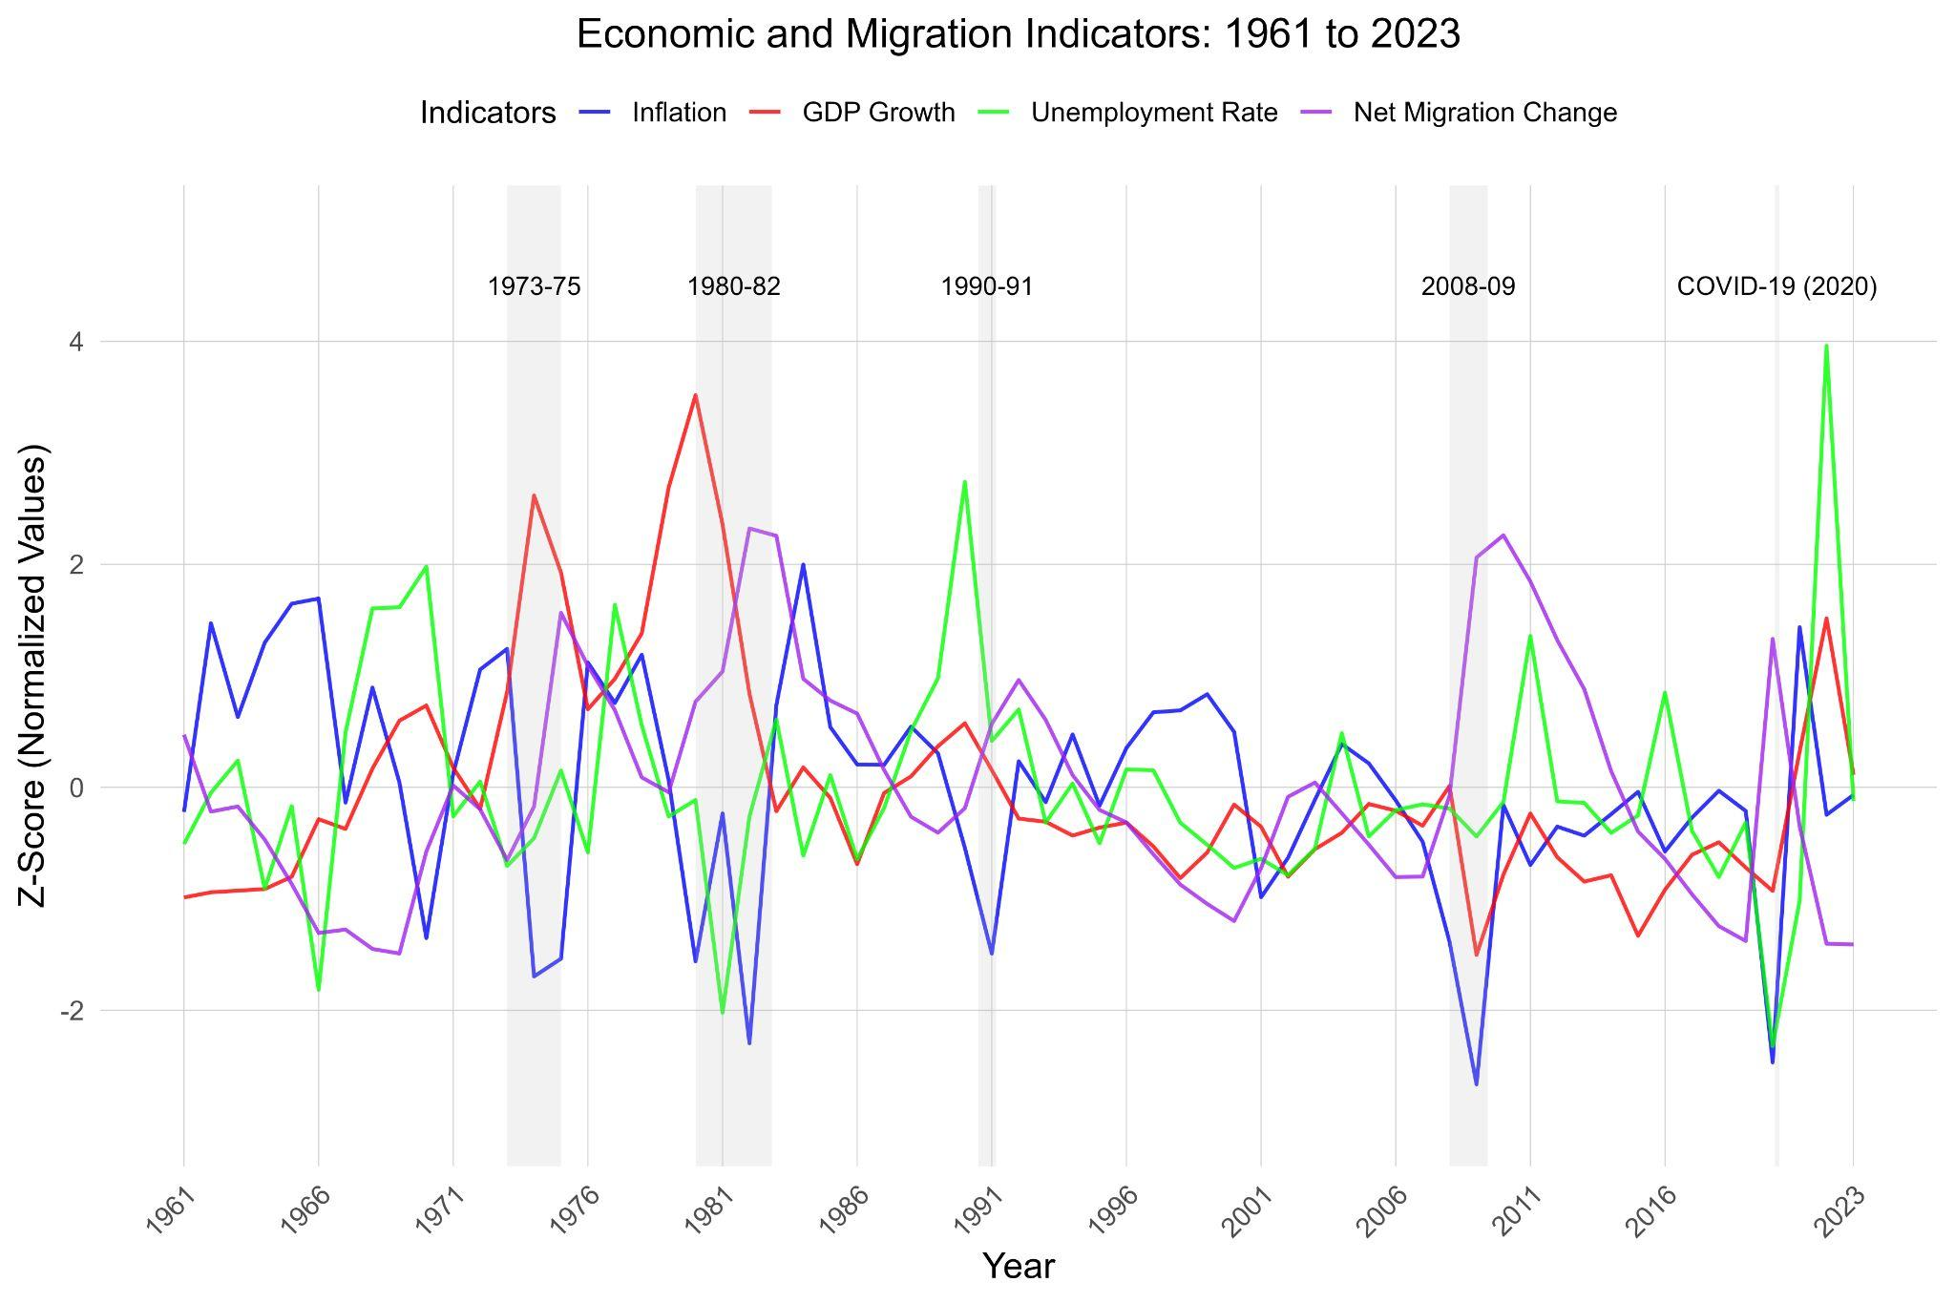

**Note:** *The values on the y-axis were standardized using the z-score formula.*

The parts highlighted in gray represent recessionary periods in the United States. Inflation (blue line) shows a steep decline during the 1973-75 and 1980–82 periods, as a result of oil price shocks from the OPEC embargo on the U.S. and the Iranian Revolution. GDP Growth (red line) decreases in all of the recessions, which could be caused by the housing bubble crisis of 2008 and COVID-19 pandemic. On the other hand, Unemployment Rate (Green line) increases during recessionary periods. During 2020, for example, many businesses had to close down or cut off the number of people working because of the pandemic. Finally, Net Migration (purple line) also increases during times of a recession, which is possibly explained by the decrease in the cost of living during periods of economic turmoil. Also, in 1990, immigration in the United States grew rapidly because of the passage of the Immigration Act of 1990. This act increased the number of legal immigrants by allocating 10,000 visas for special immigrants annually and 10,000 for job-seeking investors.

**1.3 Methods**

Our response variable in out model is economic growth, which is represented by real GDP. On the other hand, our explanatory variables are Net Migration, Unemployment Rate and Inflation. Every variable is displayed as a percentage. Our main predictor variable of interest is Net migration.

𝚫**Real GDP** ​= β0 + β1​ Net Migration ​+ β2​ Unemployment Rate ​+ β3​​ Inflation + 𝜖

* **β**0:Represents the intercept of the equation when the explanatory variables are equal to 0.
* **β1​𝚫Net Migration:** An increase in net migration to the United States, in the short run, will positively influence GDP growth due to an increase in consumption and economic activity. Because the equation for net migration measures immigrants minus emigrants we can expect: a) Net migration to increase, meaning the number of immigrants is greater than the number of emigrants. This could have a mixed effect on economic growth, as it can potentially lower wage levels, but it could also fill labor shortages. If there is a surplus of workers, compared to the demand for labor, unemployment will increase, impacting GDP. b) If net migration is decreasing, then the number of emigrants is greater than the number of immigrants. The effect of people leaving the country could decrease total expenditure, resulting in lower total consumption. However, this effect on the economy is also offset by people coming in. In the long run, there is an equilibrium in net migration.
* **β2​ ​Unemployment Rate:** In terms of the unemployment rate, we expect to find an inverse relationship with GDP Growth, because if there are fewer people employed, then there is also less disposable income. When that occurs, individuals are less inclined to make purchases, which reduces economic activity. The decrease in economic activity negatively impacts GDP growth.
* **β**3​​ **Inflation**: The higher the percentage change in CPI, the lower the GDP growth will be in the short run because of the increase in prices, or in other words, inflation.
* 𝜖: Represents the residual error of our model. It is the difference between our response variable and predicted values.

**1.4 Analysis of Results**

**Single model:**

1. 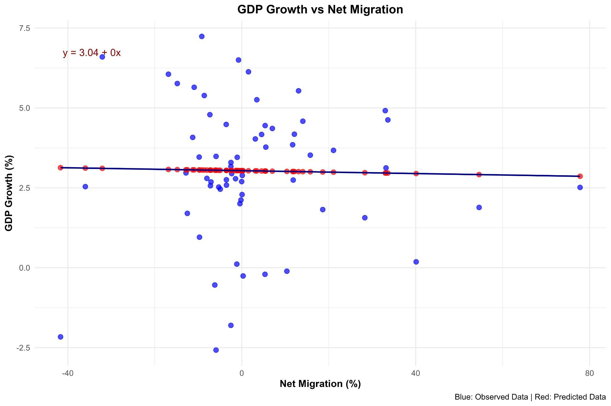**GDP Growth vs Net Migration**

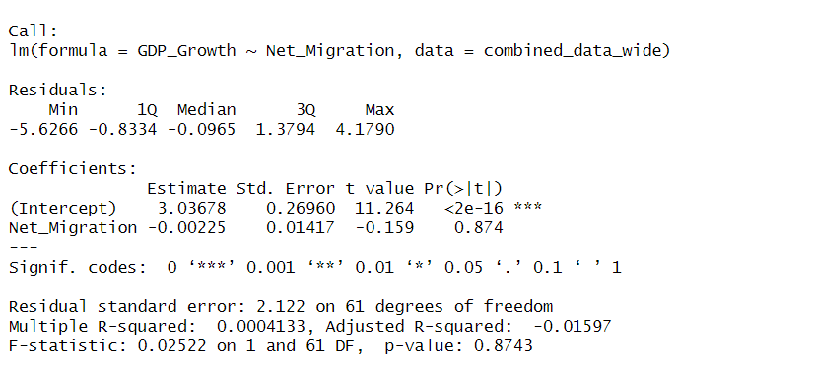

**a)Null Hypothesis**: There is no relationship between Net Migration and GDP Growth.  
 H0: β1=0

β1​ is the coefficient for Net Migration

**b) Alternative Hypothesis**: There is a relationship between Net Migration and GDP Growth.  
 H0: β1≠ 0

**c) Analysis:**

* The F-statistic is 0.02522, and has a p-value of 0.874, which is far greater than the significance level 0.05. Therefore, we fail to reject the null hypothesis. The Adjusted R-squared value is −0.01597, which indicates that the model does not explain any of the variability in the GDP Growth.
* For every one unit of increase in net migration, there will be a decrease of 0 in Real GDP. Therefore, Net Migration alone can not explain changes in Real GDP. As shown by the given equation: Y= 3.04 +0x , where 3.04 is the intercept and 0 is the slope.
* Similarly the density plot—see appendix—shows non-linearity in the data and is skewed to the left, which means that the models overpredict the observed values.

**Note:** For other individual single models of unemployment and inflation: see appendix

1. **Multivariable model**

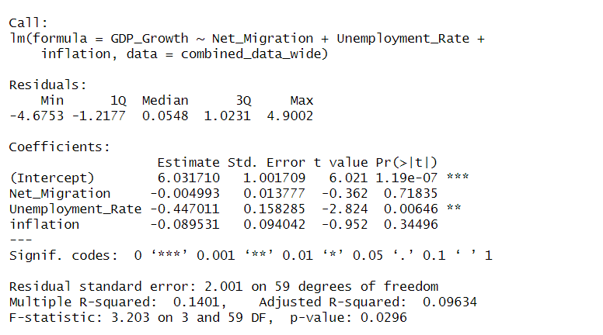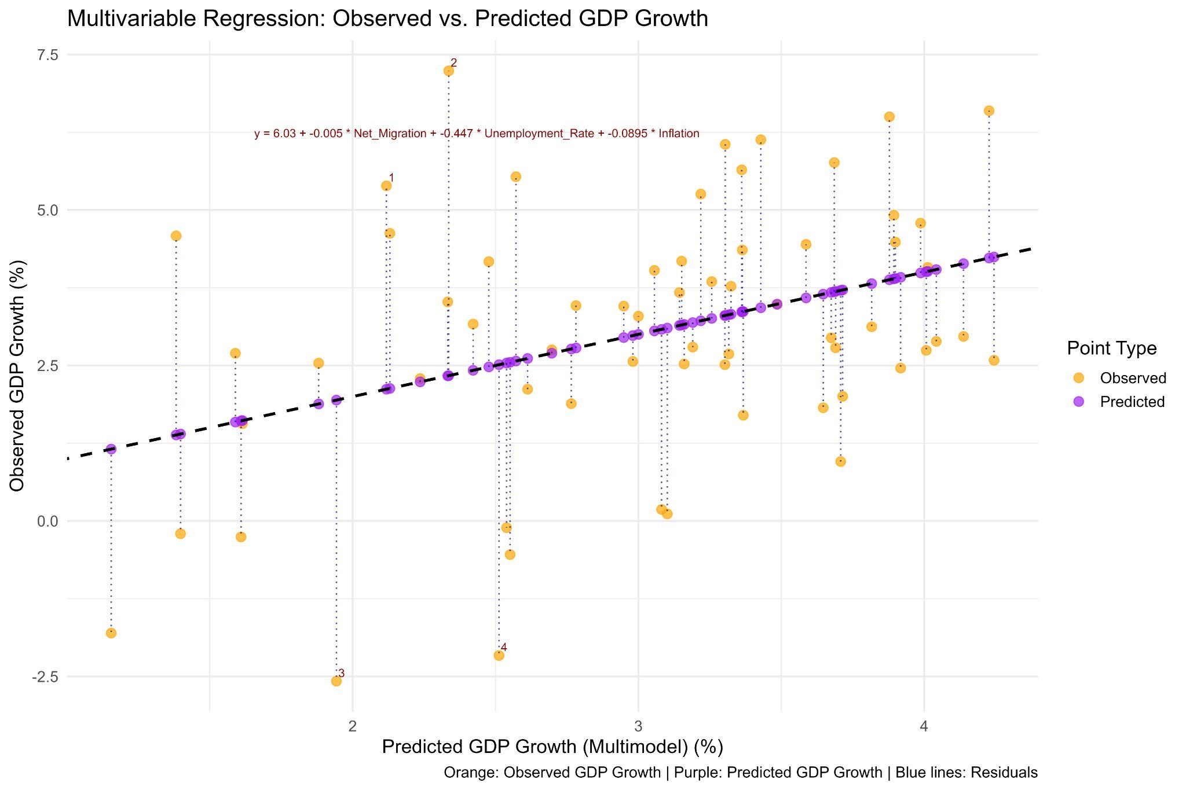

**a)Null Hypothesis**: There is no relationship between Net Migration, Unemployment Rate, Inflation, and GDP growth.  
 H0:β1,β2, β3=0

β1​ is the coefficient for Net Migration, β2​ is the coefficient for the Unemployment Rate, and β3 for inflation.

**b) Alternative Hypothesis**: There is a relationship between Net Migration, Unemployment Rate, Inflation, and GDP growth.  
 H0:β1,β2, β3≠ 0

**C) Analysis:**

* The intercept indicates that when Net Migration, Unemployment Rate, and Inflation are all zero, the predicted GDP Growth is approximately 6.03%.
* The Adjusted R-squared is 0.09634 , which is a modest improvement compared to the previous model. It suggests that the model explains approximately 9.63% of the variability in GDP Growth.
* The F-statistic is 3.203 with a p-value of 0.0296. This indicates that the model as a whole is statistically significant at the 5% level, meaning that at least one of the predictors has a meaningful relationship with GDP Growth.
* The Unemployment Rate has a strong negative effect on GDP Growth. Here, a 1 unit increase leads to a decrease of about 0.45%, with high statistical significance, since p-value is 0.00646 (p < 0.05).
* Net Migration shows little negative effect on GDP growth. Here, a 1-unit increase corresponds to a decrease of approximately 0.004993, which rounded to two decimal places is an increase of 0% in GDP. It is not significant, since the p-value= 0.71835 (p > 0.05), therefore we fail to reject the null hypothesis.
* An increase in one unit of inflation, decreases GDP growth by 0.09%. It has a p-value of 0.34496. (p > 0.05), thus we fail to reject the null hypothesis. There is no evidence to support the correlation between inflation and GDP Growth.
* The residuals are nearly symmetrical, which means the model does not over or underestimate the dependent variable.

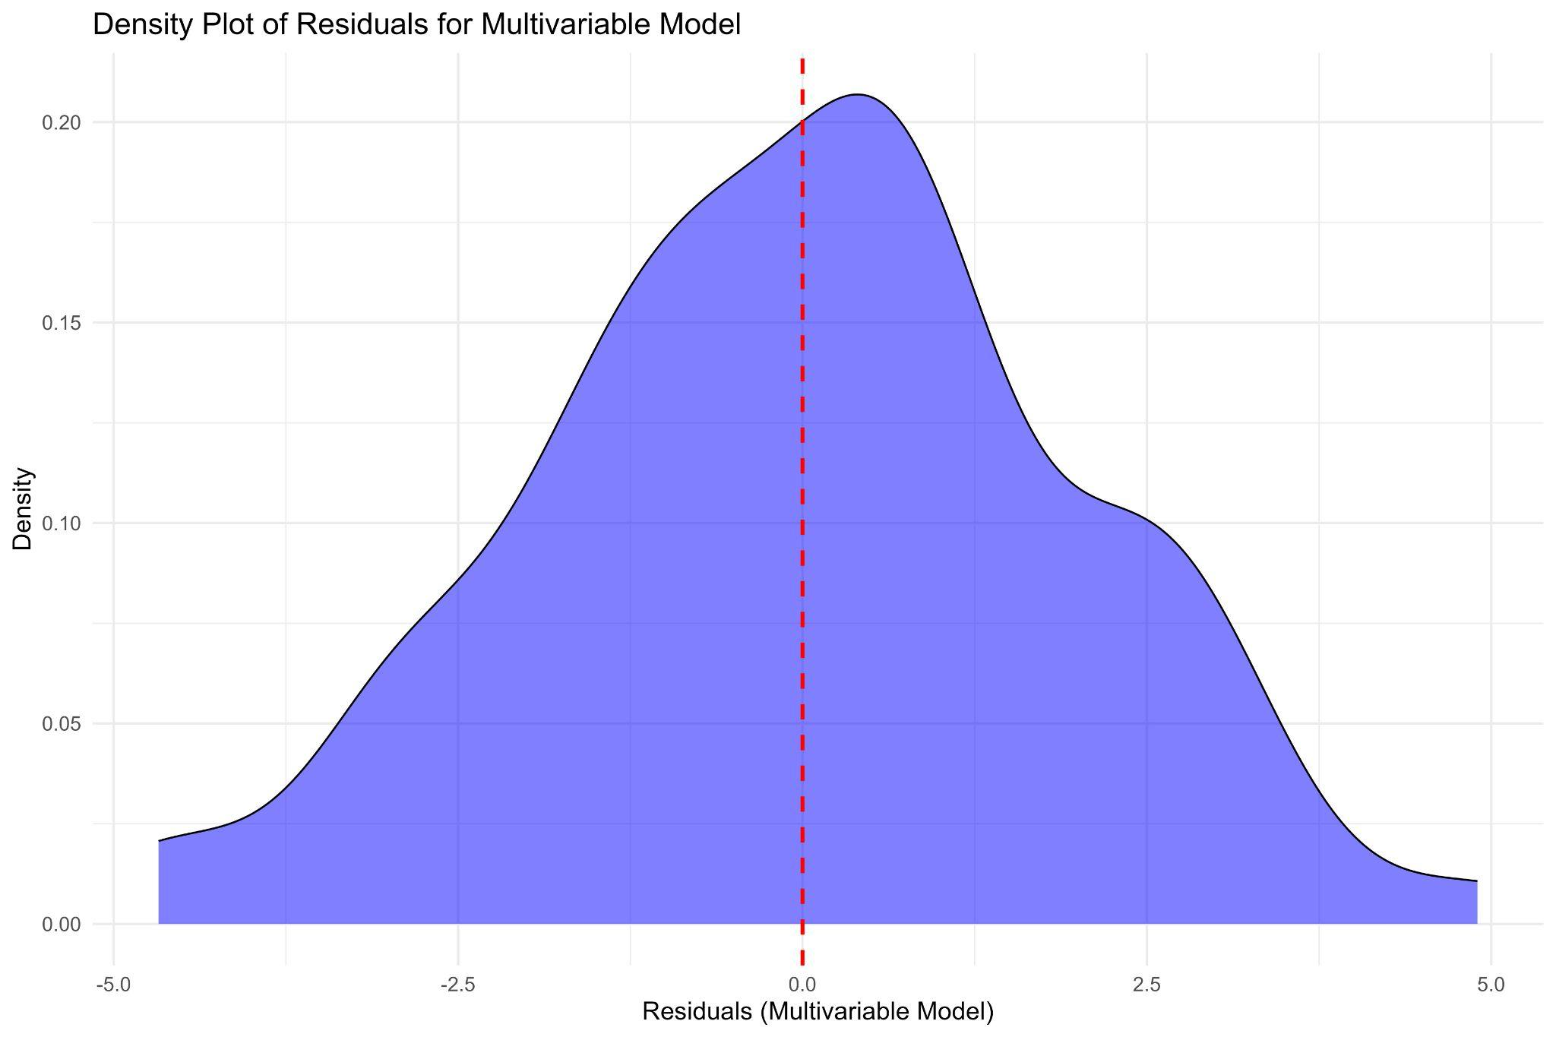

**1.5. Conclusion**

In conclusion, our results suggest that out of all of our explanatory variables, the unemployment rate has the most significant impact on the decline of economic growth; although, the rise in any of the variables shows a decrease in economic growth to some extent. Besides, our main variable of interest—Net Migration—showed a weak relationship with the variability of GDP growth. This could happen if the proportions of inflows and outflows are relatively proportional over the selected periods of time. On the other hand, inflation also showed no statistical significance, which could be explained by monetary and fiscal policy that has stabilized the economy or other confounding variables that have a stronger effect. As a result, we propose the following recommendations:

* The usage of other regression models in cases with outliers. For instance, R provides the rlm() model to deal with spread data, and glm() models to reduce how noisy the data is. The latter applies logistic parameters, without mutating the nature of the explanatory variables. In this case, it could be particularly useful for Net_Migration because its standard deviation is high. Besides, the least square sum could be optimized–with the optim() function– to better fit the model.
* Before coming up with the models, we could examine the correlation between the variables with the cor() to see if it is positive or negative. This will allow us to evaluate the presence of meaningful results.
* In this model: 𝚫Real GDP ​= β0 + β1​ Net Migration ​+ β2​ Unemployment Rate ​+ β3​​ Inflation + 𝜖, Real GDP is our response variable, however, we could also see the other way around. For example, 𝚫Net Migration ​= β0 + β1​Real GDP​ + β2​ Unemployment Rate ​+ β3​​ Inflation + 𝜖 where Net Migration becomes our new response variable. This new approach will bring more interesting insights with regard to Net Migration, our main variable of interest.

**1.7. Appendix**

1.7.1) Sources

Unemployment Rate: <https://fred.stlouisfed.org/series/UNRATE>, annual percent, FRED data

Real GDP: <https://fred.stlouisfed.org/graph/?g=1aEiA>, percent change from a year ago, FRED data

Inflation: <https://fred.stlouisfed.org/series/FPCPITOTLZGUSA> , percent, FRED data

Net Migration: <https://data.worldbank.org/indicator/SM.POP.NETM?locations=us> , percent change, World Bank

**1.7.2) Individual data visualizations** 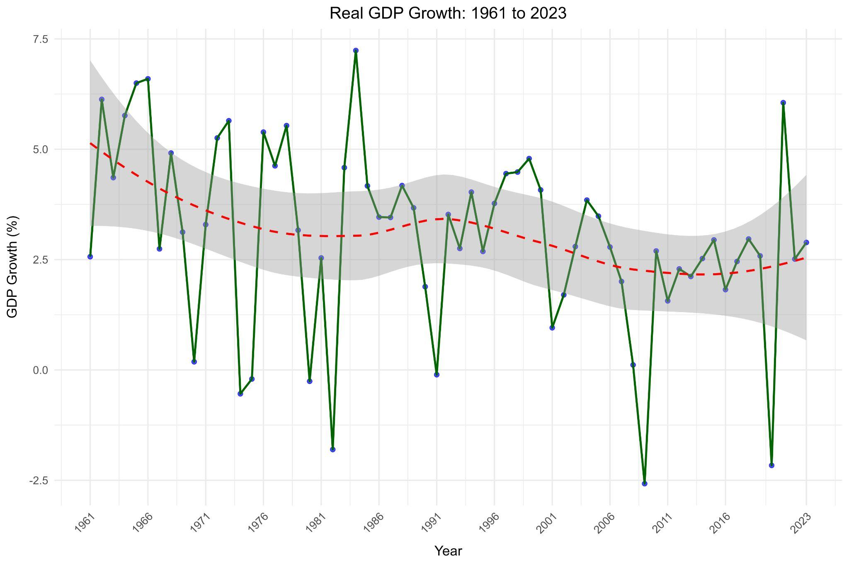

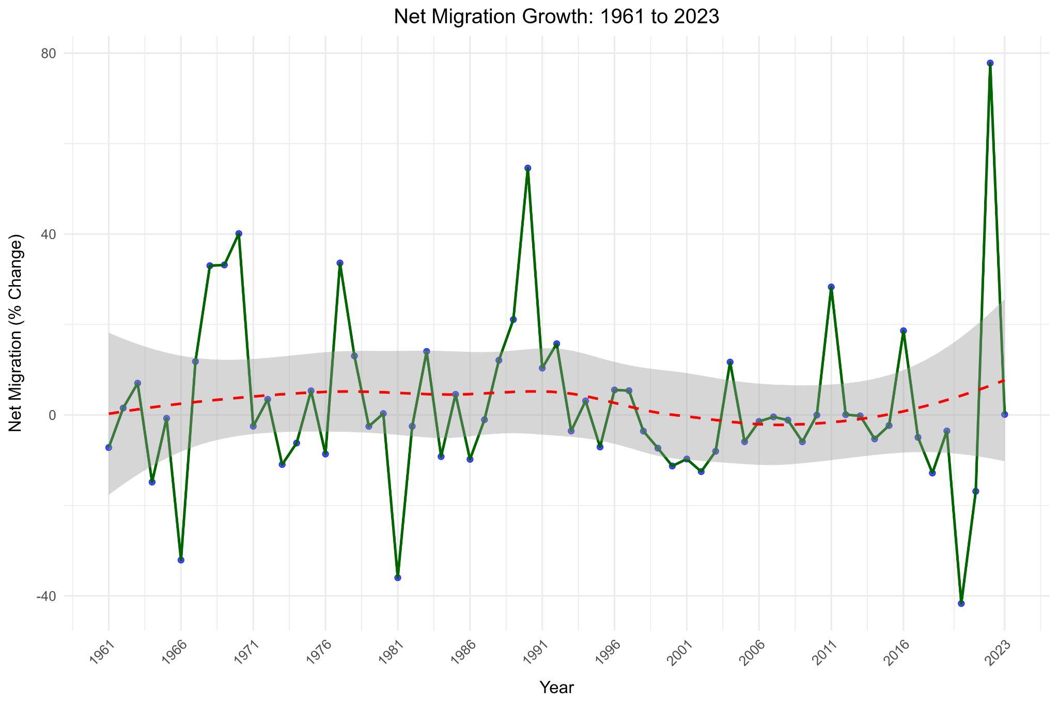

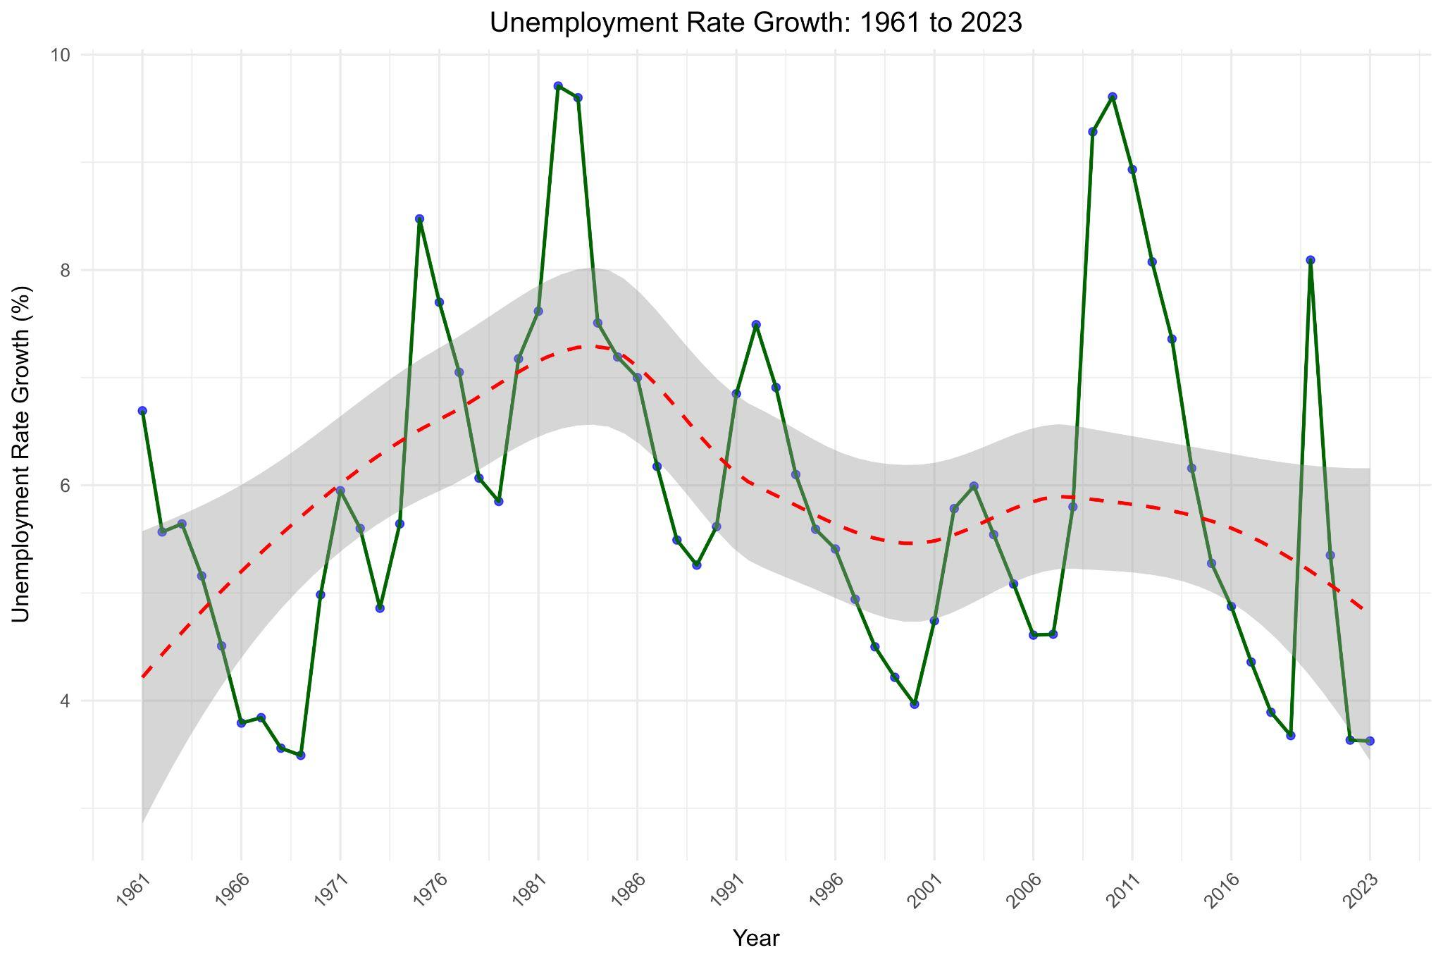

**1.7.3 Other Single models:**

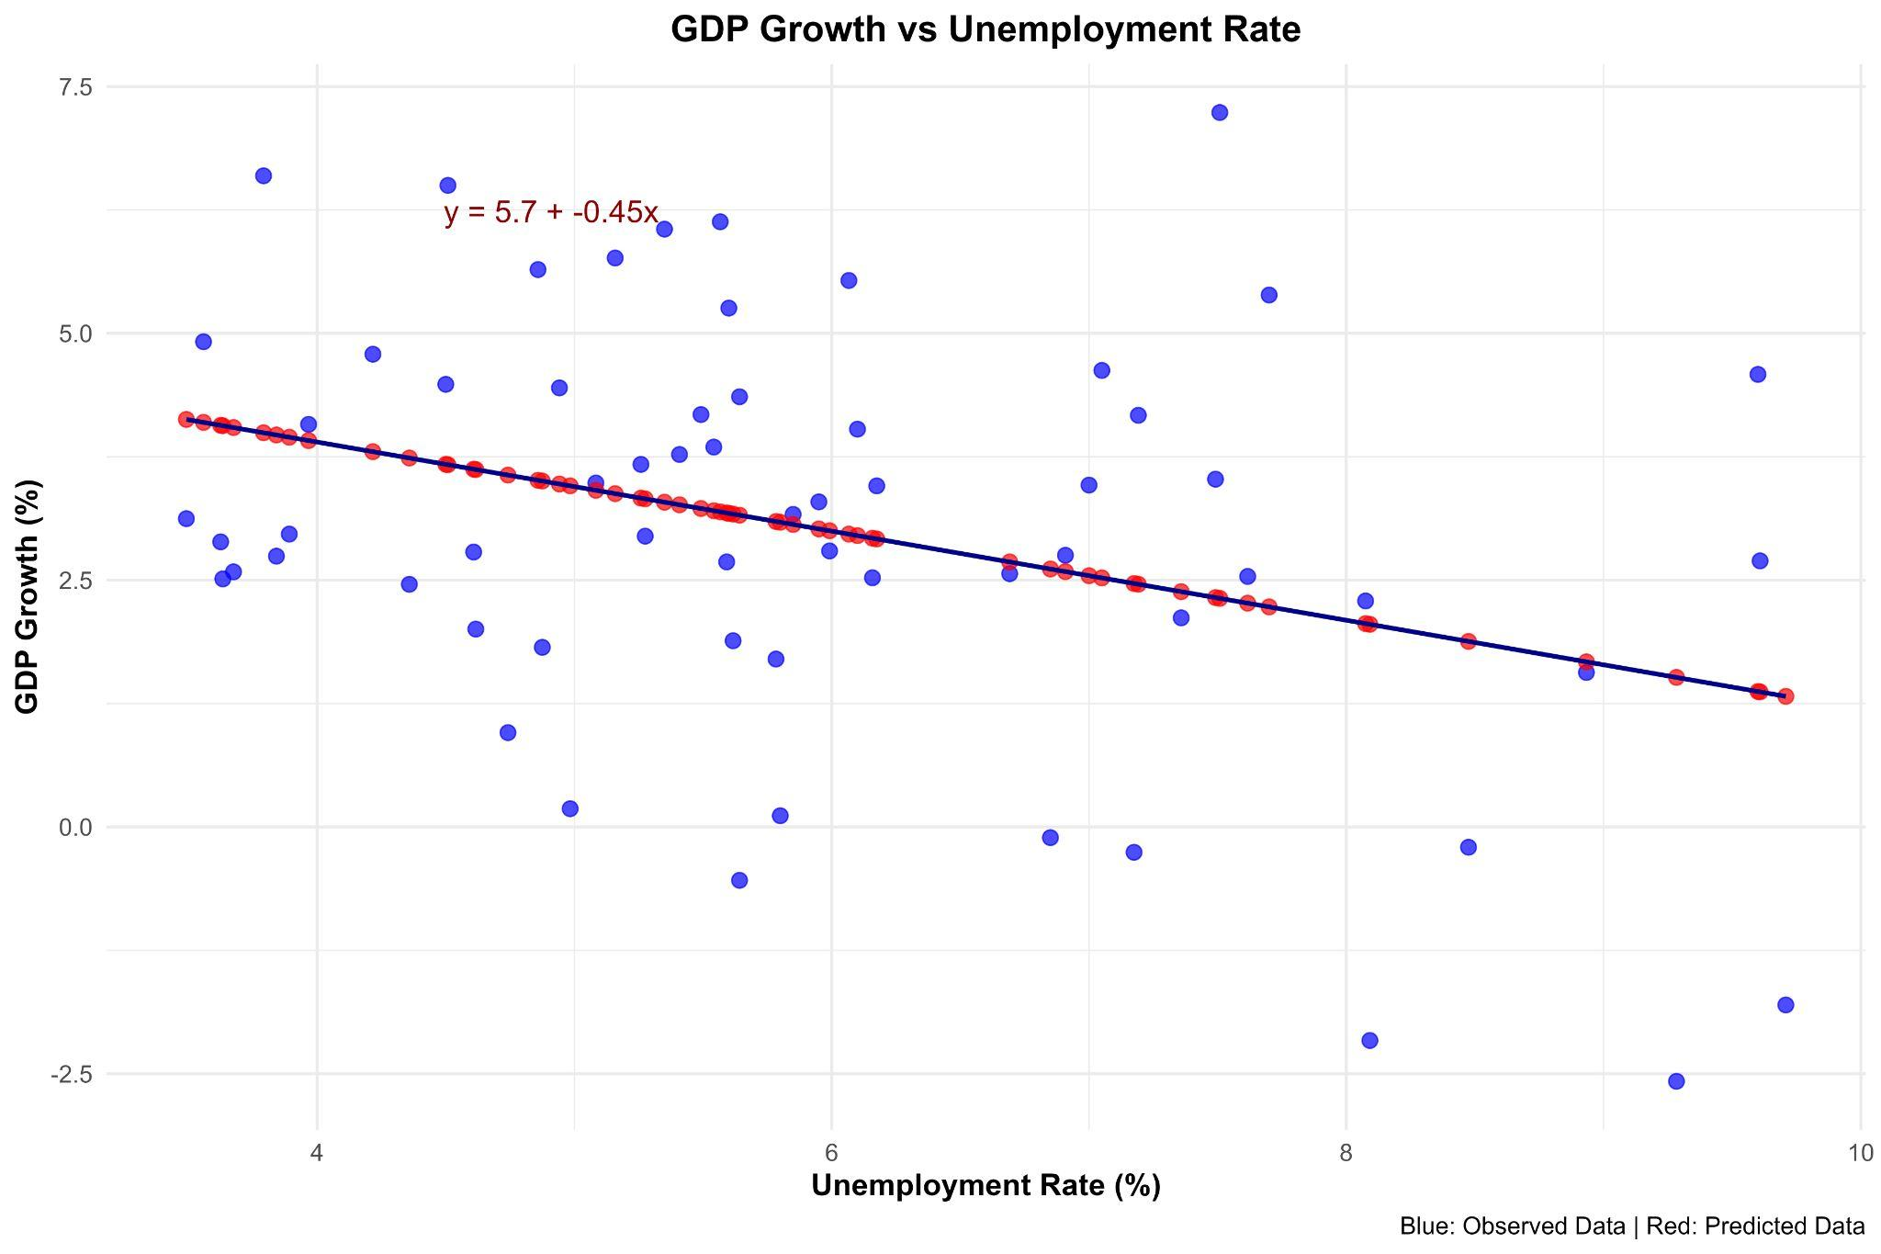**GDP Growth vs Unemployment**

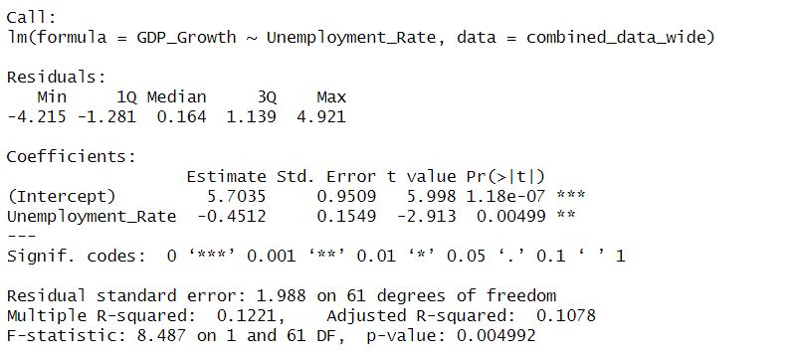

**a)Null Hypothesis**: There is not a relationship between Unemployment rate and GDP growth.  
 H0:β1=0

β1​ is the coefficient for Unemployment Rate

**b) Alternative Hypothesis**: There is a relationship between Unemployment Rate and GDP growth.  
 H0:β1≠ 0

**c) Analysis:**

* The p-value is **1.18e-07**, which is extremely small. It tends to 0. Since P-Value < 0.05 we **reject the null hypothesis**.
* For every one unit of increase in unemployment, there will be a decrease of 0.4512 % in Real GDP, holding other variables constant. As shown by the given equation: Y= 5.7 +(-0.45)x , where 5.7 is the intercept and -0.45 is the slope. Note that this has been rounded to two decimal places.
* Similarly the density plot shows a strong relationship due to the fact that residuals are symmetrically distributed around 0. Therefore, the model is unbiased. 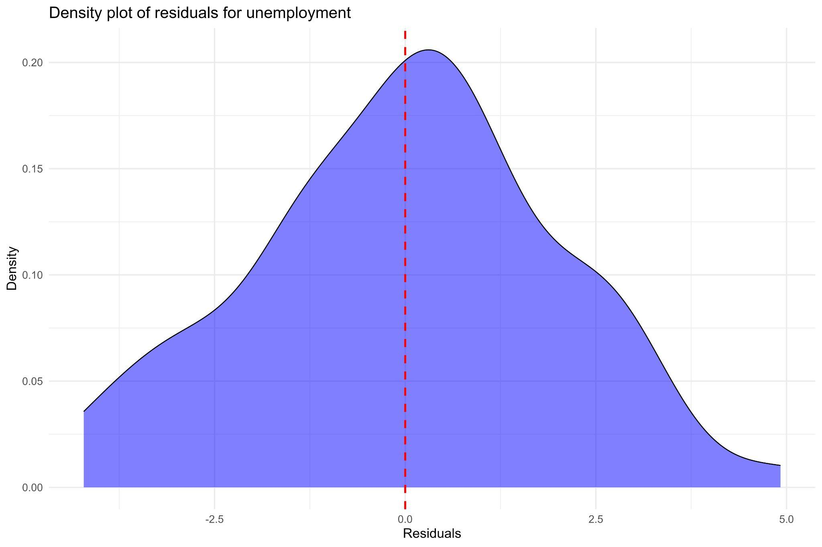

**GDP Growth vs Inflation**

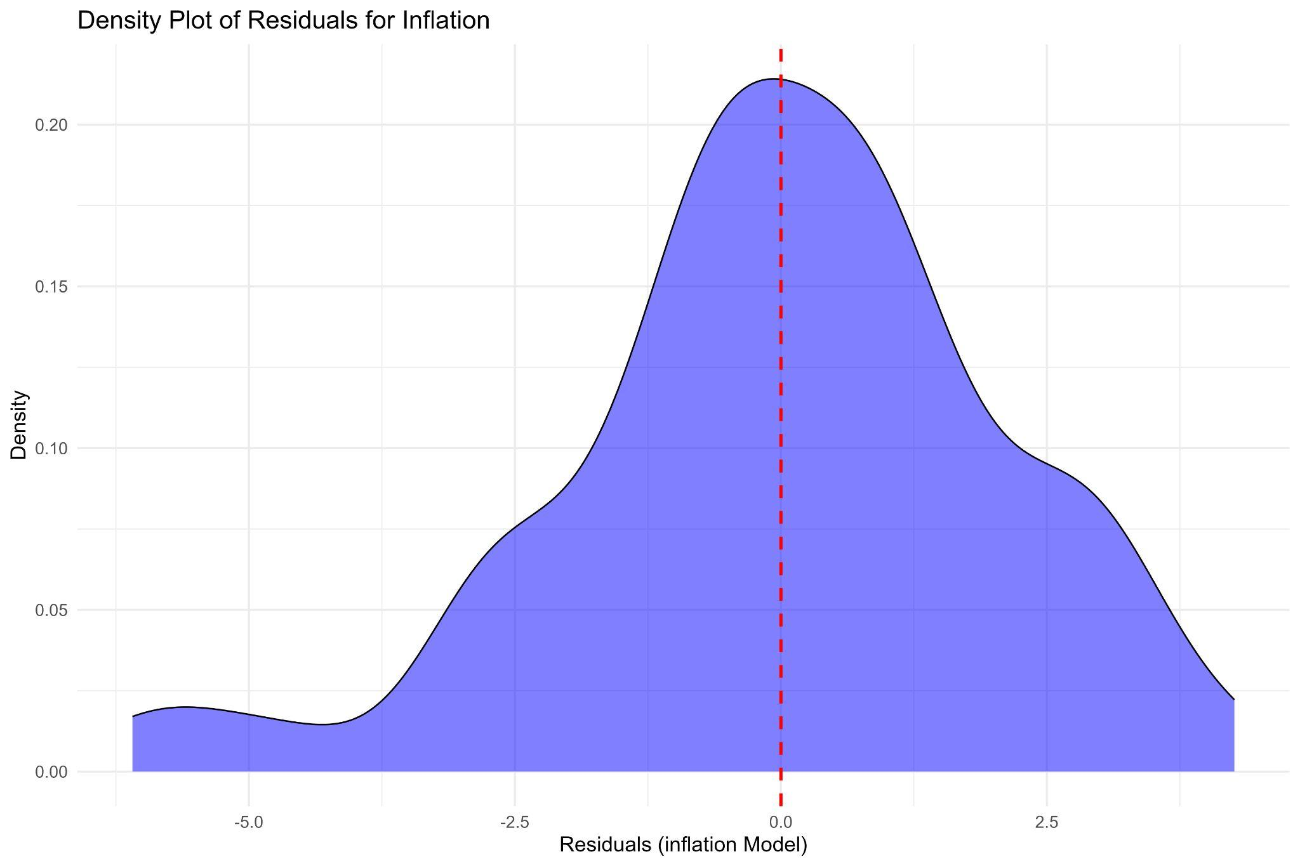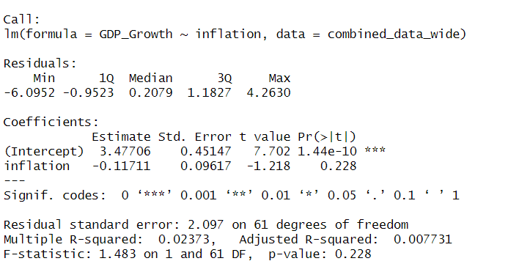 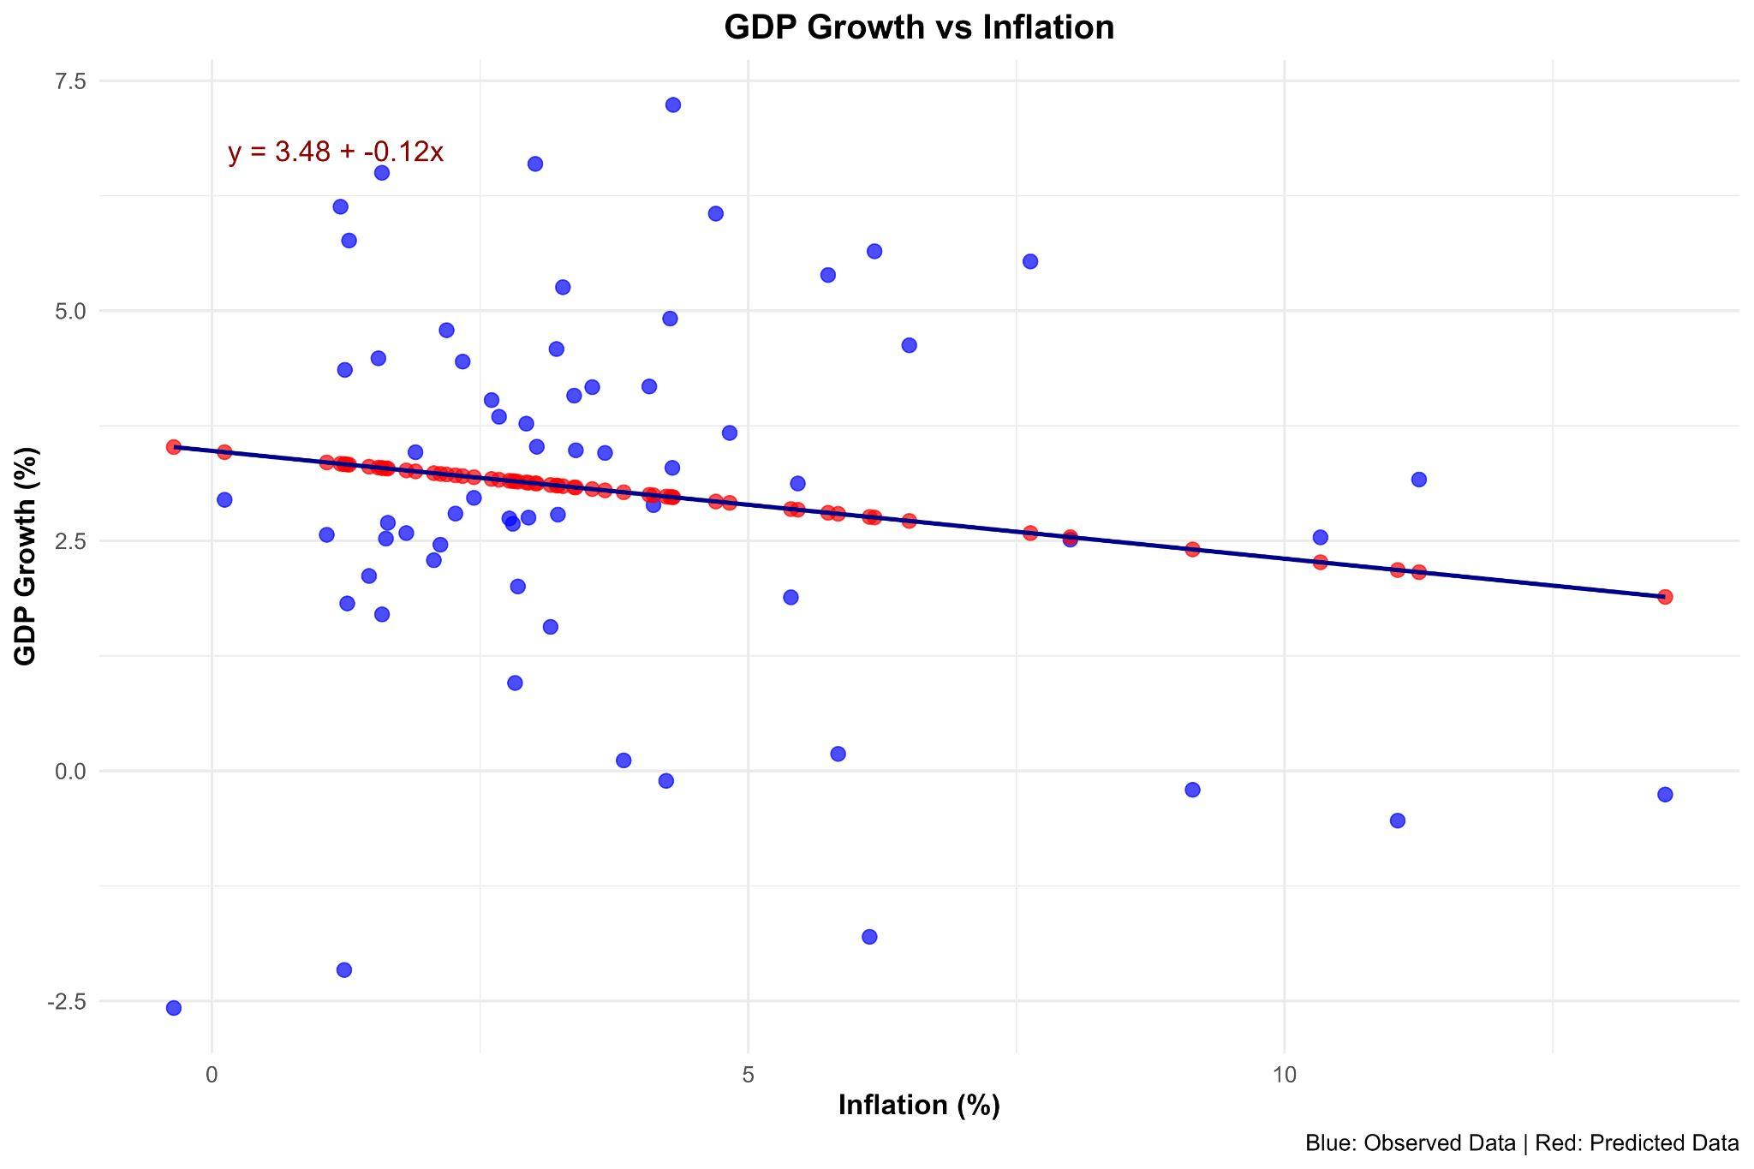

**a)Null Hypothesis**: There is no relationship between Inflation and GDP Growth.  
 H0:β1=0

β1​ is the coefficient for CPI growth

**b) Alternative Hypothesis**: There is a relationship between Inflation and GDP Growth.  
 H0:β1≠ 0

**c) Analysis:**

* The p-value (0.228) is greater than our significance level of 0.05, thus we fail to reject the null hypothesis. Under this approach, there is not a statistically significant relationship between this explanatory variable and the observed variable, unless other predictors are included. For every one unit of increase in unemployment, there will be a decrease of 0.12 % in Real GDP, holding other variables constant. Besides, the residual plot is mostly symmetrical.

**REFERENCES**

Federal Reserve Bank of St. Louis. *Unemployment Rate [UNRATE]*. FRED, Federal Reserve Bank of St. Louis. Retrieved December 8, 2024, from<https://fred.stlouisfed.org/series/UNRATE>

Federal Reserve Bank of St. Louis. *Real GDP, Percent Change from a Year Ago*. FRED, Federal Reserve Bank of St. Louis. Retrieved December 8, 2024, from<https://fred.stlouisfed.org/graph/?g=1aEiA>

Federal Reserve Bank of St. Louis. *Inflation (Consumer Prices, Annual %)*. FRED, Federal Reserve Bank of St. Louis. Retrieved December 8, 2024, from<https://fred.stlouisfed.org/series/FPCPITOTLZGUSA>

World Bank. *Net Migration [SM.POP.NETM]*. World Bank Open Data. Retrieved December 8, 2024, from<https://data.worldbank.org/indicator/SM.POP.NETM?locations=us>